# Introduction to Version Control with GitHub

Create a userid on GitHub (github.com) and follow the HelloWorld guide. Some instructions to help you are below.

## How to register a GitHub userid:

* Open the github.com web page on your computer like this:

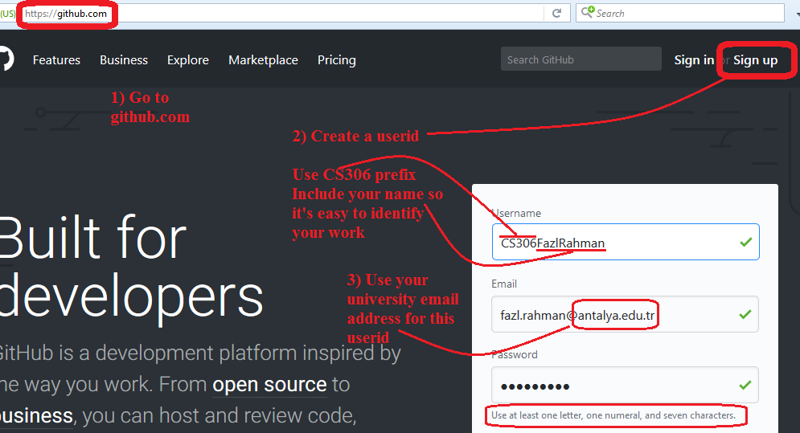

* On the next page, choose the **free** plan.
* On the next page, you can do this:

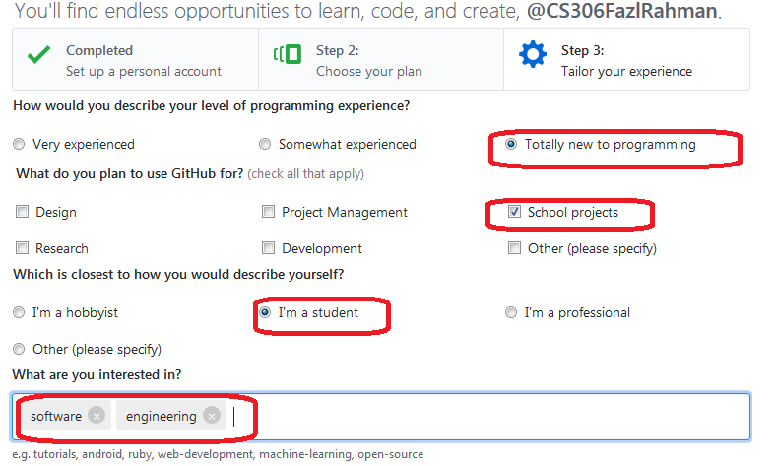

NB you will have to open your university email account to **verify your address** before you can proceed with the below steps.

(You can update your user profile to include your name and uploading a distinctive profile picture can later help others to recognise your contributions.)

* Next choose the **GitHub guide**:

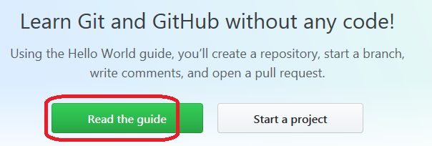

This claims it is a 10min read but it's *better to do it slowly and understand* the steps..

Follow the guide to:

* create your own project repository
* create a feature branch for a new task (simple edits to the readme file)
* create a 'pull request' so a team member can check your changes
* accept your changes (you the whole team for this exercise!) into the master branch
* delete the feature branch once you have merged the changes

If you have problems you can bring your laptop computer to campus next Monday (19/2/2018) at 12pm to Room A2-91